**Exercise 7: Packages**

**Scenario 1:** Group all customer-related procedures and functions into a package.

* + **Question:** Create a package **CustomerManagement** with procedures for adding a new customer, updating customer details, and a function to get customer balance.

**Scenario1 Code:**

BEGIN

EXECUTE IMMEDIATE 'DROP TABLE Customers';

EXCEPTION

WHEN OTHERS THEN NULL;

END;

/

-- Create Customers table

CREATE TABLE Customers (

CustomerID NUMBER PRIMARY KEY,

Name VARCHAR2(100),

DOB DATE,

Balance NUMBER

);

-- Create CustomerManagement package specification

CREATE OR REPLACE PACKAGE CustomerManagement AS

PROCEDURE AddCustomer(p_CustomerID NUMBER, p_Name VARCHAR2, p_DOB DATE, p_Balance NUMBER);

PROCEDURE UpdateCustomer(p_CustomerID NUMBER, p_Name VARCHAR2, p_DOB DATE, p_Balance NUMBER);

FUNCTION GetCustomerBalance(p_CustomerID NUMBER) RETURN NUMBER;

END CustomerManagement;

/

-- Create CustomerManagement package body

CREATE OR REPLACE PACKAGE BODY CustomerManagement AS

PROCEDURE AddCustomer(p_CustomerID NUMBER, p_Name VARCHAR2, p_DOB DATE, p_Balance NUMBER) IS

BEGIN

INSERT INTO Customers VALUES (p_CustomerID, p_Name, p_DOB, p_Balance);

END;

PROCEDURE UpdateCustomer(p_CustomerID NUMBER, p_Name VARCHAR2, p_DOB DATE, p_Balance NUMBER) IS

BEGIN

UPDATE Customers SET Name = p_Name, DOB = p_DOB, Balance = p_Balance

WHERE CustomerID = p_CustomerID;

END;

FUNCTION GetCustomerBalance(p_CustomerID NUMBER) RETURN NUMBER IS

v_balance NUMBER;

BEGIN

SELECT Balance INTO v_balance FROM Customers WHERE CustomerID = p_CustomerID;

RETURN v_balance;

END;

END CustomerManagement;

/

-- Test CustomerManagement

BEGIN

CustomerManagement.AddCustomer(1, 'John Doe', DATE '1990-01-01', 5000);

CustomerManagement.UpdateCustomer(1, 'John Doe Jr.', DATE '1990-01-01', 6000);

DBMS_OUTPUT.PUT_LINE('Customer Balance: ' || CustomerManagement.GetCustomerBalance(1));

END;

/

**Scenario1 Output:**

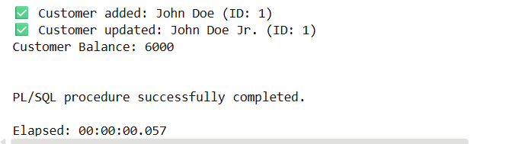

**Scenario 2:** Create a package to manage employee data.

* **Question:** Write a package **EmployeeManagement** with procedures to hire new employees, update employee details, and a function to calculate annual salary.

**Scenario 2 Code:**

BEGIN

EXECUTE IMMEDIATE 'DROP TABLE Employees';

EXCEPTION

WHEN OTHERS THEN NULL;

END;

/

-- Create Employees table

CREATE TABLE Employees (

EmployeeID NUMBER PRIMARY KEY,

Name VARCHAR2(100),

Salary NUMBER

);

-- Create EmployeeManagement package specification

CREATE OR REPLACE PACKAGE EmployeeManagement AS

PROCEDURE HireEmployee(p_EmployeeID NUMBER, p_Name VARCHAR2, p_Salary NUMBER);

PROCEDURE UpdateEmployee(p_EmployeeID NUMBER, p_Name VARCHAR2, p_Salary NUMBER);

FUNCTION CalculateAnnualSalary(p_EmployeeID NUMBER) RETURN NUMBER;

END EmployeeManagement;

/

-- Create EmployeeManagement package body

CREATE OR REPLACE PACKAGE BODY EmployeeManagement AS

PROCEDURE HireEmployee(p_EmployeeID NUMBER, p_Name VARCHAR2, p_Salary NUMBER) IS

BEGIN

INSERT INTO Employees VALUES (p_EmployeeID, p_Name, p_Salary);

END;

PROCEDURE UpdateEmployee(p_EmployeeID NUMBER, p_Name VARCHAR2, p_Salary NUMBER) IS

BEGIN

UPDATE Employees SET Name = p_Name, Salary = p_Salary

WHERE EmployeeID = p_EmployeeID;

END;

FUNCTION CalculateAnnualSalary(p_EmployeeID NUMBER) RETURN NUMBER IS

v_salary NUMBER;

BEGIN

SELECT Salary INTO v_salary FROM Employees WHERE EmployeeID = p_EmployeeID;

RETURN v_salary * 12;

END;

END EmployeeManagement;

/

-- Test EmployeeManagement

BEGIN

EmployeeManagement.HireEmployee(101, 'Alice', 50000);

EmployeeManagement.UpdateEmployee(101, 'Alice Smith', 55000);

DBMS_OUTPUT.PUT_LINE('AnnualSalary : ' ||EmployeeManagement.CalculateAnnualSalary(101));

END;

/

**Scenario 2 output:**

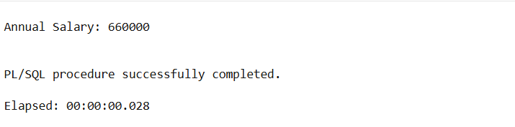

**Scenario 3:** Group all account-related operations into a package.

* **Question:** Create a package **AccountOperations** with procedures for opening a new account, closing an account, and a function to get the total balance of a customer across all accounts.

**Scenario 3 code:**

BEGIN

EXECUTE IMMEDIATE 'DROP TABLE Accounts';

EXCEPTION

WHEN OTHERS THEN NULL;

END;

/

-- Create Accounts table

CREATE TABLE Accounts (

AccountID NUMBER PRIMARY KEY,

CustomerID NUMBER,

Balance NUMBER

);

-- Create AccountOperations package specification

CREATE OR REPLACE PACKAGE AccountOperations AS

PROCEDURE OpenAccount(p_AccountID NUMBER, p_CustomerID NUMBER, p_Balance NUMBER);

PROCEDURE CloseAccount(p_AccountID NUMBER);

FUNCTION GetTotalBalance(p_CustomerID NUMBER) RETURN NUMBER;

END AccountOperations;

/

-- Create AccountOperations package body

CREATE OR REPLACE PACKAGE BODY AccountOperations AS

PROCEDURE OpenAccount(p_AccountID NUMBER, p_CustomerID NUMBER, p_Balance NUMBER) IS

BEGIN

INSERT INTO Accounts VALUES (p_AccountID, p_CustomerID, p_Balance);

END;

PROCEDURE CloseAccount(p_AccountID NUMBER) IS

BEGIN

DELETE FROM Accounts WHERE AccountID = p_AccountID;

END;

FUNCTION GetTotalBalance(p_CustomerID NUMBER) RETURN NUMBER IS

v_total NUMBER := 0;

BEGIN

SELECT NVL(SUM(Balance),0) INTO v_total FROM Accounts WHERE CustomerID = p_CustomerID;

RETURN v_total;

END;

END AccountOperations;

/

-- Test AccountOperations

BEGIN

AccountOperations.OpenAccount(201, 1, 3000);

AccountOperations.OpenAccount(202, 1, 4000);

DBMS_OUTPUT.PUT_LINE('Total Balance for Customer 1: ' || AccountOperations.GetTotalBalance(1));

AccountOperations.CloseAccount(201);

DBMS_OUTPUT.PUT_LINE('Total Balance after closing one account: ' || AccountOperations.GetTotalBalance(1));

END;

/

**Scenario 3 output:**

